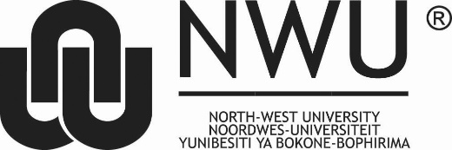
ECLM feedback questionnaire 2021
Introduction
The aim of Research Ethics Committees at the NWU is to ensure that “all research conducted under its auspices is conducted in accordance with national and international ethics standards and statutory requirements and in line with its Vision and Mission” (NWU Research Ethics Policy, 2021). The Ethics Committee for Language Matters (ECLM) in the Faculty of Humanities requests feedback on your experiences as applicant/supervisor of applicants for the period October 2020 to September 2021. The feedback questionnaire is submitted anonymously, so we invite honest feedback with ideas for possible solutions to problems (if raised) to improve our processes.

Please complete this questionnaire and to ensure anonymity, please make an arrangement with a few colleagues/students to submit their questionnaire responses together to:
- Ms Theresa Louw (Theresa.louw@nwu.ac.za) or
- Prof Susan Coetzee-Van Rooy (susan.coetzeevanrooy@nwu.ac.za)
before 15 October 2021.

- Have you submitted an application or supported a student who submitted an application to the ECLM in the past year (October 2020-September 2021)? Please tick () the most appropriate response below.

Yes | 1 | No | 2

- What was your role in the recent application (October 2020 – September 2021) to the ECLM?

Student applicant | 1
Staff member applicant | 2
Supervisor assisting student applicant | 3
Project leader assisting sub-project applicant | 4
Other (please specify below) | 5

- Have you attended ethics training/information sessions offered at the NWU or other institutions in the period October 2020-September 2021?

Yes | 1 | No | 2

- Please indicate your level of satisfaction with all of the following steps/elements that form part of the ECLM application process.

ECLM step/element in process | Not applicable | Very dissatisfied | Dissatisfied | Neither dissatisfied / satisfied | Satisfied | Very satisfied
Easy access to information about ECLM process and forms | 0 | 1 | 2 | 3 | 4 | 5
Easy access to information about ECLM training/information sessions | 0 | 1 | 2 | 3 | 4 | 5
Clarity of ECLM application documents | 0 | 1 | 2 | 3 | 4 | 5
Effectiveness of communication with ECLM officers (administrator, chair) | 0 | 1 | 2 | 3 | 4 | 5
Turn-around time from application to decision | 0 | 1 | 2 | 3 | 4 | 5
Clarity of decisions (either for revision and resubmission, or final decisions) | 0 | 1 | 2 | 3 | 4 | 5
Support during the ECLM application process | 0 | 1 | 2 | 3 | 4 | 5

- Are there any other matters related to the work of the ECLM that you would like bring to the attention of the faculty? If you raise problems, please also provide ideas for solutions.

THANK YOU for providing feedback on the ECLM processes and elements in the process for the period October 2020 to September 2021. We appreciate your feedback and will use the information to improve our processes continuously.

